Weather explains inter-annual variability, but not the temporal decline, in insect biomass

François Duchenne*1, Colin Fontaine, Benoit Fontaine, Grégoire Loïs & Emmanuelle Porcher

*1Swiss Federal Institute for Forest, Snow and Landscape Research (WSL),* *8903 Birmensdorf, Switzerland*

[francois.duchenne@wsl.ch](mailto:francois.duchenne@wsl.ch)

*: corresponding author, [francois.duchenne@wsl.ch](mailto:francois.duchenne@wsl.ch%20)

ARISING FROM J. Müller et al. *Nature* [https://doi.org/10.1038/s41586-023-06402-z](https://doi.org/10.1038/s41586-023-06402-z%20) (2023)

**Competing interests statement:**

The author declares no competing interests.

**Author contributions:**

FD performed the analyses and did the figures and wrote the manuscript with the help of all authors.

**Code availability statement:**

The R code to perform the analyses are provided as supplementary material.

**Data availability statement:**

The data are available with the original publication, [https://doi.org/10.1038/s41586-023-06402-z](https://doi.org/10.1038/s41586-023-06402-z%20).

# Main

In a recent publication1, Müller *et al.* re-analysed, in light of new data, the dataset of the highly cited paper of Hallmann *et al.*2, who showed a strong decline in insect biomass in Germany between 1989 and 2016. Müller *et al.* presented a re-analysis of the data from Hallmann *et al.* adding weather conditions as predictors and conclude that the temporal variations in insect biomass are mostly explained by weather conditions. Here we present arguments that explain why we think their analysis was unsuitable to draw such conclusion, because unmodelled drivers that should be accounted for. More appropriate analyses produce a pattern opposite to the main message of Müller *et al.*: there is a significant temporal decline in insect biomass that is not explained by weather conditions and habitats conditions played a significant role in the observed decline.

Müller *et al.*’s completed the model used by Hallmann *et al.* by precisely modelling the effect of weather conditions on insect biomass, using 12 parameters, including time-lagged effects and interaction among variables. They also extracted the habitat variables used by Hallmann *et al.* to account for temporal changes in habitat conditions. Although these variables provide a poor overview of how habitat conditions of sampled sites changed over time2, they were a noble effort to model habitat change while data are missing at such spatio-temporal scales. Coupled with the use of two independent datasets to train and validate their model, it makes the article of Müller *et al.* a nice attempt to unravel the drivers of temporal dynamics of insect biomass. Their analyses clearly show that climatic conditions have a major impact on insect biomass. However, Müller *et al.* did not control for missing drivers of insect biomass in their model, which is likely to bias the estimated effects.

## A strong temporal decline in insect biomass not explained by weather conditions

Müller *et al.* argue that weather conditions were the only important driver of temporal changes in insect biomass, because when weather conditions were included in their model, the residuals exhibited no temporal trend (model 5 of their study). Estimating the temporal trend in the residuals is a hierarchical approach prone to bias because there is a known temporal trend in weather conditions due to climate change. The statistical fit, which seeks to explain as much variance as possible with the available variables, is likely to attribute any temporal change in insect biomass to temporal changes in weather conditions. Thus, the absence of temporal trend in the residuals is not informative on the importance of non-modelled drivers. For example, agriculture intensification is a likely driver of insect biomass, but Hallmann *et al.*, and Müller *et al.* as well, could not model its effect because temporal metrics are missing2. Agricultural intensification has been confirmed as an important driver of insect biomass, especially pesticide use3–5, which is correlated with time which can lead to confounding effects.

Simultaneously estimating temporal trend in insect biomass and effects of weather conditions, by adding a linear year effect to Müller *et al.*’s model, indicates that there is a significant decline in insect biomass over time (-4.0%.year-1) that is not explained by weather conditions (Fig. 1a and Table 1), while improving the fit of the model (lower AIC, Table 1). This temporal trend is not informative of the possible drivers of the temporal decline but indicates that insect biomass declined by 4% per year because of unknown factors. A similar result is obtained when modelling remaining temporal signal using a random effect of the year instead of linear trend, as estimated random effects shows a negative temporal trend: recent years being more prone to show negative deviations to average than old years (Fig. 1b).

The temporal trend estimated here is not informative of the mechanism driving it and thus cannot be used to extrapolate biomass data in other area with different characteristic. However, it is important to notice that even when including a year effect, the weather conditions are still a good predictor of the insect biomass of the validation dataset (Fig. 1c). This confirms that weather conditions are a good predictor of inter-annual variability in insect biomass, but the remaining significant temporal effect suggest that weather conditions are not 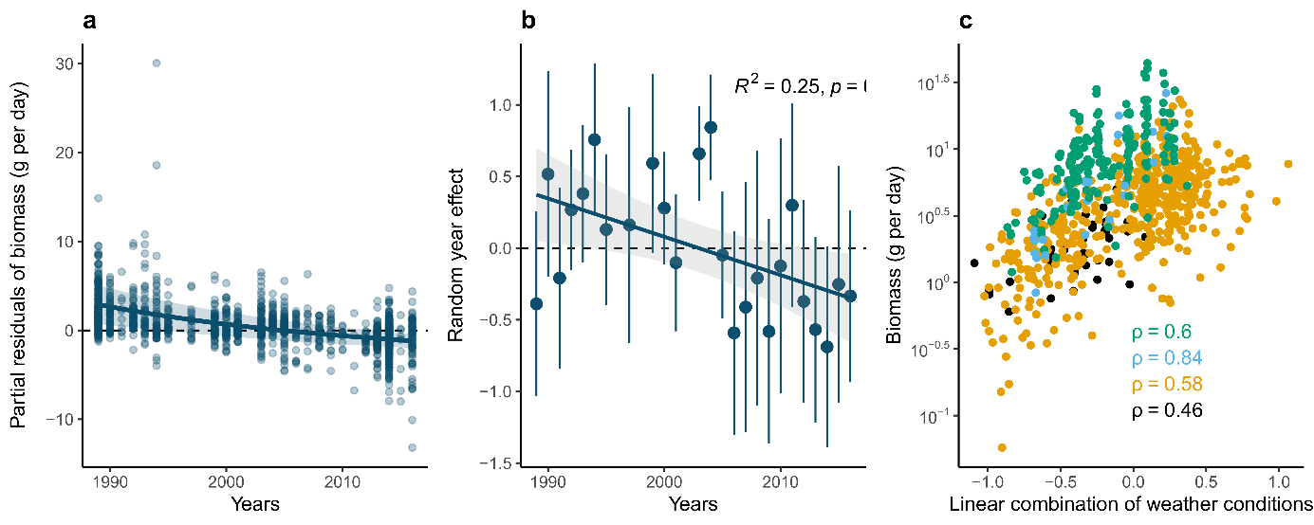driving the observed decline in insect biomass.

***Fig. 1: The temporal trend in insect biomass is significantly negative when the effects of weather are accounted for.*** *(a) the partial residuals of biomass, i.e. the amount of biomass not explained by other predictors, as a function of year. Line and ribbon show the model prediction and its 95% confidence interval, respectively. (b) Year random effects (deviation from average intercept on the link scale) ordered temporally. Error bars are 95% confidence intervals. The line and ribbon show the prediction and its 95% confidence interval respectively, from a linear model (random effects ~ year). (c) Observed biomass from the validation dataset, as a function of a linear combination of the weather conditions based on the training data (black = 2016, yellow = 2019, light blue=2020, green = 2022). Spearman correlation coefficient and associated p-values are indicated.*

***Table 1: Model estimates and goodness of fit for the model of Müller et al. and for the modified version, with an additional linear year effect.***

|  |  |  |  |  |  |  |
| --- | --- | --- | --- | --- | --- | --- |
| Variable | Model 5 from Müller et al. | | | Modified model 5 | | |
| Estimate | Stde | p-value | Estimate | Stde | p-value |
| Number of herb species | 0.0008 | 0.0011 | 0.4763 | -0.0022 | 0.0011 | **0.0377** |
| Number of tree species | 0.1174 | 0.0121 | **0.0000** | 0.0515 | 0.0143 | **0.0003** |
| Ellenberg value light | 0.1469 | 0.0646 | **0.0232** | 0.0529 | 0.0635 | 0.4051 |
| Ellenberg value temperature | -0.0351 | 0.0406 | 0.3867 | 0.0702 | 0.0408 | 0.0857 |
| Proportion of arable land | -0.3530 | 0.1108 | **0.0015** | -0.0808 | 0.1130 | 0.4746 |
| Proportion of forest | -0.1493 | 0.1139 | 0.1899 | 0.0630 | 0.1139 | 0.5803 |
| Proportion of grassland | 0.3484 | 0.1161 | **0.0027** | 0.2487 | 0.1129 | **0.0277** |
| Proportion of water | 0.2816 | 0.1479 | 0.0571 | 0.0364 | 0.1448 | 0.8016 |
| *T* | 0.0814 | 0.0062 | **0.0000** | 0.0844 | 0.0060 | **0.0000** |
| *P* | -0.0033 | 0.0008 | **0.0000** | -0.0025 | 0.0007 | **0.0007** |
| *T* × *P* | -0.0001 | 0.0002 | 0.7482 | 0.0000 | 0.0002 | 0.8560 |
| *T* ano. winter | -0.2943 | 0.0268 | **0.0000** | -0.1232 | 0.0321 | **0.0001** |
| *P* ano. winter | 0.0339 | 0.0026 | **0.0000** | 0.0197 | 0.0030 | **0.0000** |
| *T* ano. winter × *P* ano. winter | -0.0114 | 0.0025 | **0.0000** | -0.0021 | 0.0026 | 0.4187 |
| *T* ano. April cur | 0.0820 | 0.0261 | **0.0017** | 0.0810 | 0.0237 | **0.0007** |
| *P* ano. April cur | 0.0148 | 0.0016 | **0.0000** | 0.0068 | 0.0017 | **0.0000** |
| *T* ano. April cur × *P* ano. April cur | -0.0028 | 0.0009 | **0.0036** | -0.0003 | 0.0009 | 0.7761 |
| *T* ano. April prev. | -0.1082 | 0.0303 | **0.0004** | 0.0155 | 0.0301 | 0.6073 |
| *P* ano. April prev. | 0.0021 | 0.0015 | 0.1477 | 0.0028 | 0.0014 | **0.0405** |
| *T* ano. April prev. × *P* ano. April prev. | -0.0044 | 0.0008 | **0.0000** | -0.0014 | 0.0008 | 0.0932 |
| *T* ano. month prev. | -0.0078 | 0.0119 | 0.5135 | -0.0059 | 0.0117 | 0.6134 |
| *P* ano. month prev. | -0.0009 | 0.0004 | **0.0369** | -0.0001 | 0.0004 | 0.7498 |
| *T* ano. month prev. × *P* ano. month prev. | -0.0006 | 0.0003 | **0.0419** | -0.0001 | 0.0003 | 0.7196 |
| Year | not included | | | -0.0411 | 0.0048 | **0.0000** |
| R2 | 0.6543 | | | 0.6661 | | |
| AIC | 13156.2570 | | | 13101.6760 | | |

*T*, temperature; *P*, precipitation; ano., anomalies; cur, year of sampling; prev., the month of the sampling day but in the previous year; Stde, Standard Error. Bold pvalues highlight significant effects (p-value < 0.05) and brightness of the color of the “Estimate” column is proportional to the magnitude of the estimate (red for negative and blue for positive effects).

## Contributions of weather and habitat conditions in long-term trend in insect biomass

Müller *et al.* also claimed to show that weather conditions are the main drivers of the temporal changes in insect biomass, whereas temporal changes in habitat conditions played a minor role only. As shown above, this is highly debatable, as an important part of the long-term decline in insect biomass correlates more with time than with any modelled drivers.

Since weather conditions, as insect biomass, exhibits strong inter-annual variations, weather conditions could drive inter-annual variability in insect biomass without being the main driver of the long-term temporal decline observed by Hallmann *et al.*2. In contrast, habitats conditions measured here (number of trees, proportion of arable land in a 200m radius, etc.) are unlikely to exhibit strong interannual variations, and thus to explain inter-annual variability in insect biomass but could be an important driver of the long-term trend.

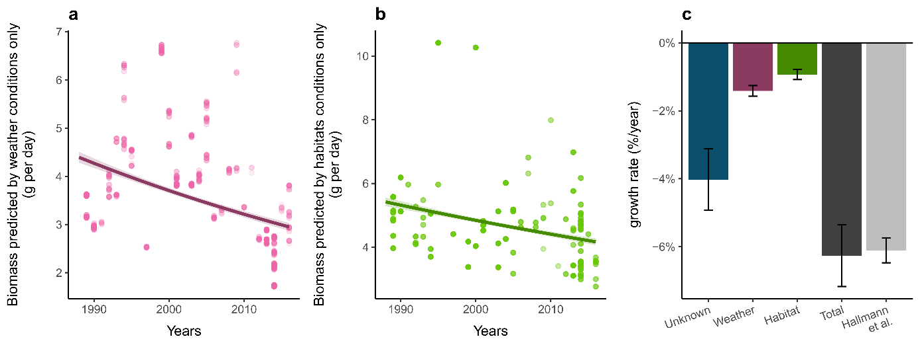To estimate the contributions of weather and habitat conditions in the long-term biomass decline, we predicted biomass according to weather conditions or habitat conditions only and estimated the temporal trend in those partial predicts. The results show that weather conditions indeed played a role in the decline observed previously by Hallmann *et al.* (-1.4%.year-1, CI95%=[-1.57,-1.26], Fig. 2a), but habitat conditions modelled by Müller *et al.* also played a significant role in that decline (-0.9%.year-1, CI95%=[-1.01,-0.78], Fig. 2b). However, these contributions to the long-term decline in insect biomass are minors relative to the part of the decline that correlates more with time than with other included drivers, i.e. the remaining temporal trend (-4.0%.year-1) estimated by the year effect, as said previously. The sum of these contributions to the long-term decline of insects is highly consistent with the decline estimated by Hallmann *et al.* (Fig. 2c).

***Fig. 2: contributions of temporal changes in weather and habitats conditions to decline in insect biomass.*** *Biomass values predicted by weather (a) or habitat (b) conditions only, using the modified model presented in Table 1, as a function of the time. The temporal trend in those values (line) is the contribution of those conditions to the long-term temporal trend in insect biomass. (c) Contributions of the remaining temporal trend (unknown mechanism), weather and habitats conditions in long-term insect decline, and their summed value (total), which is highly consistent with the one estimated by Hallman et al. (2017).*

One would note the difference in the precision of modelling weather and habitat conditions, which could easily explain why habitat conditions have a slightly smaller contribution than weather. While weather conditions are modelled using 12 parameters, including time-lagged effects and interaction among variables, habitats conditions are modelled using 8 parameters, without time-lagged effects or interactions among variables. Some variables, extracted from Hallmann *et al.*, were based on a very coarse temporal resolution. For example, proportion of habitats within the 200m radius have been calculated from two sets of aerial images, taken in 1989–1994 and 2012–2015, and yearly values have been interpolated.

## Interpreting row data can be misleading

Finally, Müller *et al.* observed that adding recently collected data (2016-2022) to Hallmann *et al.* time series, results in a non-significant decline in biomass between 1989 and 2022 based on their Figure 1. However, this figure shows two datasets collected on different geographic areas, as shown by their Extended Data Fig. 1, as a unique time series. The 1989-2016 data used by Müller *et al.* to fit their model, were mostly collected in middle-west Germany, while the 2016-2022 data, used to validate the model, were collected in south-east Germany (Fig. 3), an area that is much less anthropized than the areas in which the data of Hallmann *et al.* were collected (Fig. 3b-c). This difference alone could explain the apparent increase in insect biomass in recent data. Indeed, if included in the models presented in the Table 1, the human footprint has a strong and significant negative effects on insect biomass, consistently with previous results6.

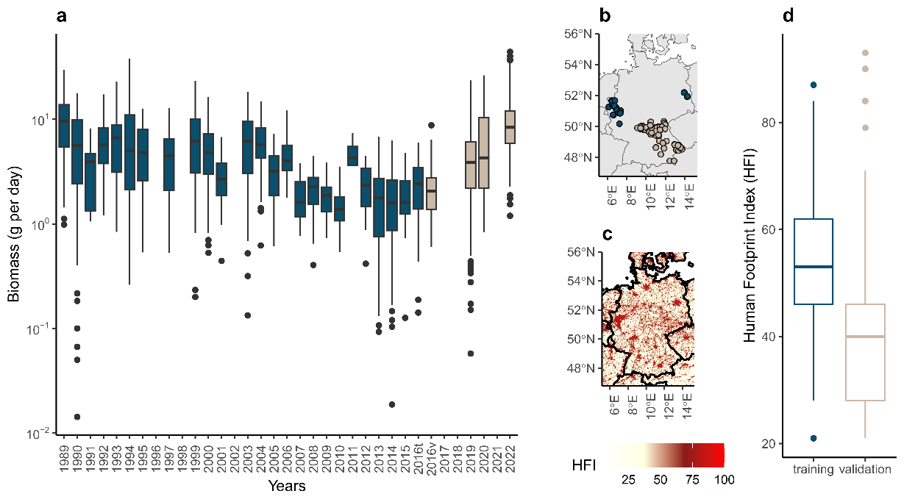However, the authors take few precautions to interpret this heterogeneous time series: “*The temporal pattern of the compiled data shows that the linear decrease reported by Hallmann et al. throughout 2016 did not continue in more recent years, but instead biomass increased from 2016 until 2022, with highest values similar to those from the late 1980s reached in 2022”*.

***Fig. 3: Misleading presentation of the initial and new datasets for insect biomass.*** *Data from Hallmann et al. (blue, training dataset in Müller et al.) and more recently collected data (beige, validation dataset in Müller et al.) were presented by Müller et al. on the same time series (a), while they were collected in different geographic areas (c), with different levels of disturbances (d, Human Footprint Index v2 1995-2004). (d) Human Footprint Index extracted for each site location from the 1km2 resolution raster plotted in (c), as function of the dataset.*

## Conclusions

In writing this comment, we do not intend to tone down the effects of weather conditions on insect biomass; they are clearly demonstrated by Müller al.’s analysis, and have been supported by other studies7,8. Analyses done by Müller *et al.* show that weather conditions strongly affect inter-annual variability in insect biomass, consistently with previous findings9–13, and that weather conditions could partially drive the observed decline in insect biomass. However, their analyses are not suited to affirm that weather conditions were the only driver of the observed decline, neither to affirm that habitats conditions played a minor role in that decline. Corrected analyses even show the opposite: most of the temporal decline in insect biomass remains unexplained, and habitats conditions played a significant role in that decline. Such kind of illegitimate conclusions, minimizing the contribution of land use change in the long-term trend of insect biomass, can be strongly deleterious for biodiversity conservation.

With this comment, we would like to remind our modest ability to model complex ecological changes. Müller *et al.* push forward in the right direction in trying to understand the drivers of the temporal decline in insect biomass using correlates with for which causal mechanisms on the response variable are theorized. However, in our view not accounting for the missing predictors, through a time effect, is likely to produce highly biased results. It is indeed hard to model precisely the effects of some global change drivers that are likely to be important because of the lack data, which the case for habitat conditions. The variables used here to model habitat conditions were for some of them at a very coarse resolution. For example the proportion of habitats within the 200m radius have been calculated from two sets of aerial images, taken in 1989–1994 and 2012–2015, and yearly values have been interpolated2.

Assessing the relative importance of drivers requires models that simultaneously include all drivers in a similar way. Since most of the global change drivers are correlated over time, this remains a challenging task. Moreover, the effects of global change drivers likely depend on each other, e.g. the effect of climate change on insect abundance is mediated by land use8. We thus stress the need to be conservative in the interpretation of results, to prevent overinterpretation of analyses that often come with many limitations, especially when analysing large scale ecological patterns. Drawing conclusions that are not properly supported by statistical findings is likely to disrupt both the scientific debate and public outreach, with possible negative consequences for the trust in scientific results on important topics for societies.

# Acknowledgement

We thank the authors of the original study, Müller *et al.*, for providing R codes and data allowing a good reproducibility of their analyses, and for their comprehensive answer. We also thank Mathilde Vimont for her helpful comments on this manuscript. FD was funded by the European Research Council (ERC) under the European Union’s Horizon 2020 research and innovation program (grant agreement N° 787638, led by C. H. Graham).

# References

1. Müller, J. *et al.* Weather explains the decline and rise of insect biomass over 34 years. *Nature* 1–6 (2023) doi:10.1038/s41586-023-06402-z.

2. Hallmann, C. A. *et al.* More than 75 percent decline over 27 years in total flying insect biomass in protected areas. *PLOS ONE* **12**, e0185809 (2017).

3. Barmentlo, S. H. *et al.* Experimental evidence for neonicotinoid driven decline in aquatic emerging insects. *Proceedings of the National Academy of Sciences* **118**, e2105692118 (2021).

4. Raven, P. H. & Wagner, D. L. Agricultural intensification and climate change are rapidly decreasing insect biodiversity. *Proceedings of the National Academy of Sciences* **118**, e2002548117 (2021).

5. Nicholson, C. C. *et al.* Pesticide use negatively affects bumble bees across European landscapes. *Nature* 1–4 (2023) doi:10.1038/s41586-023-06773-3.

6. Seibold, S. *et al.* Arthropod decline in grasslands and forests is associated with landscape-level drivers. *Nature* **574**, 671–674 (2019).

7. Lister, B. C. & Garcia, A. Climate-driven declines in arthropod abundance restructure a rainforest food web. *Proceedings of the National Academy of Sciences* **115**, E10397–E10406 (2018).

8. Outhwaite, C. L., McCann, P. & Newbold, T. Agriculture and climate change are reshaping insect biodiversity worldwide. *Nature* **605**, 97–102 (2022).

9. Stack Whitney, K. *et al.* Explicit modeling of abiotic and landscape factors reveals precipitation and forests associated with aphid abundance. *Ecological Applications* **26**, 2600–2610 (2016).

10. Fourcade, Y., Ranius, T. & Öckinger, E. Temperature drives abundance fluctuations, but spatial dynamics is constrained by landscape configuration: Implications for climate-driven range shift in a butterfly. *Journal of Animal Ecology* **86**, 1339–1351 (2017).

11. Roy, D. B., Rothery, P., Moss, D., Pollard, E. & Thomas, J. A. Butterfly numbers and weather: predicting historical trends in abundance and the future effects of climate change. *Journal of Animal Ecology* **70**, 201–217 (2001).

12. Goulson, D., Derwent, L. C., Hanley, M. E., Dunn, D. W. & Abolins, S. R. Predicting calyptrate fly populations from the weather, and probable consequences of climate change. *Journal of Applied Ecology* **42**, 795–804 (2005).

13. Jonas, J. L., Wolesensky, W. & Joern, A. Weather Affects Grasshopper Population Dynamics in Continental Grassland Over Annual and Decadal Periods. *Rangeland Ecology & Management* **68**, 29–39 (2015).